MODULE 4 – INTRODUCTION TO DBMS

LAB EXERCISES

16. Introduction To PL / SQL
Lab 1.
Write a PL / SQL block to print the total number of employees from the employees table.
Ans.
1. SELECT COUNT(*) AS total_employees FROM employees;

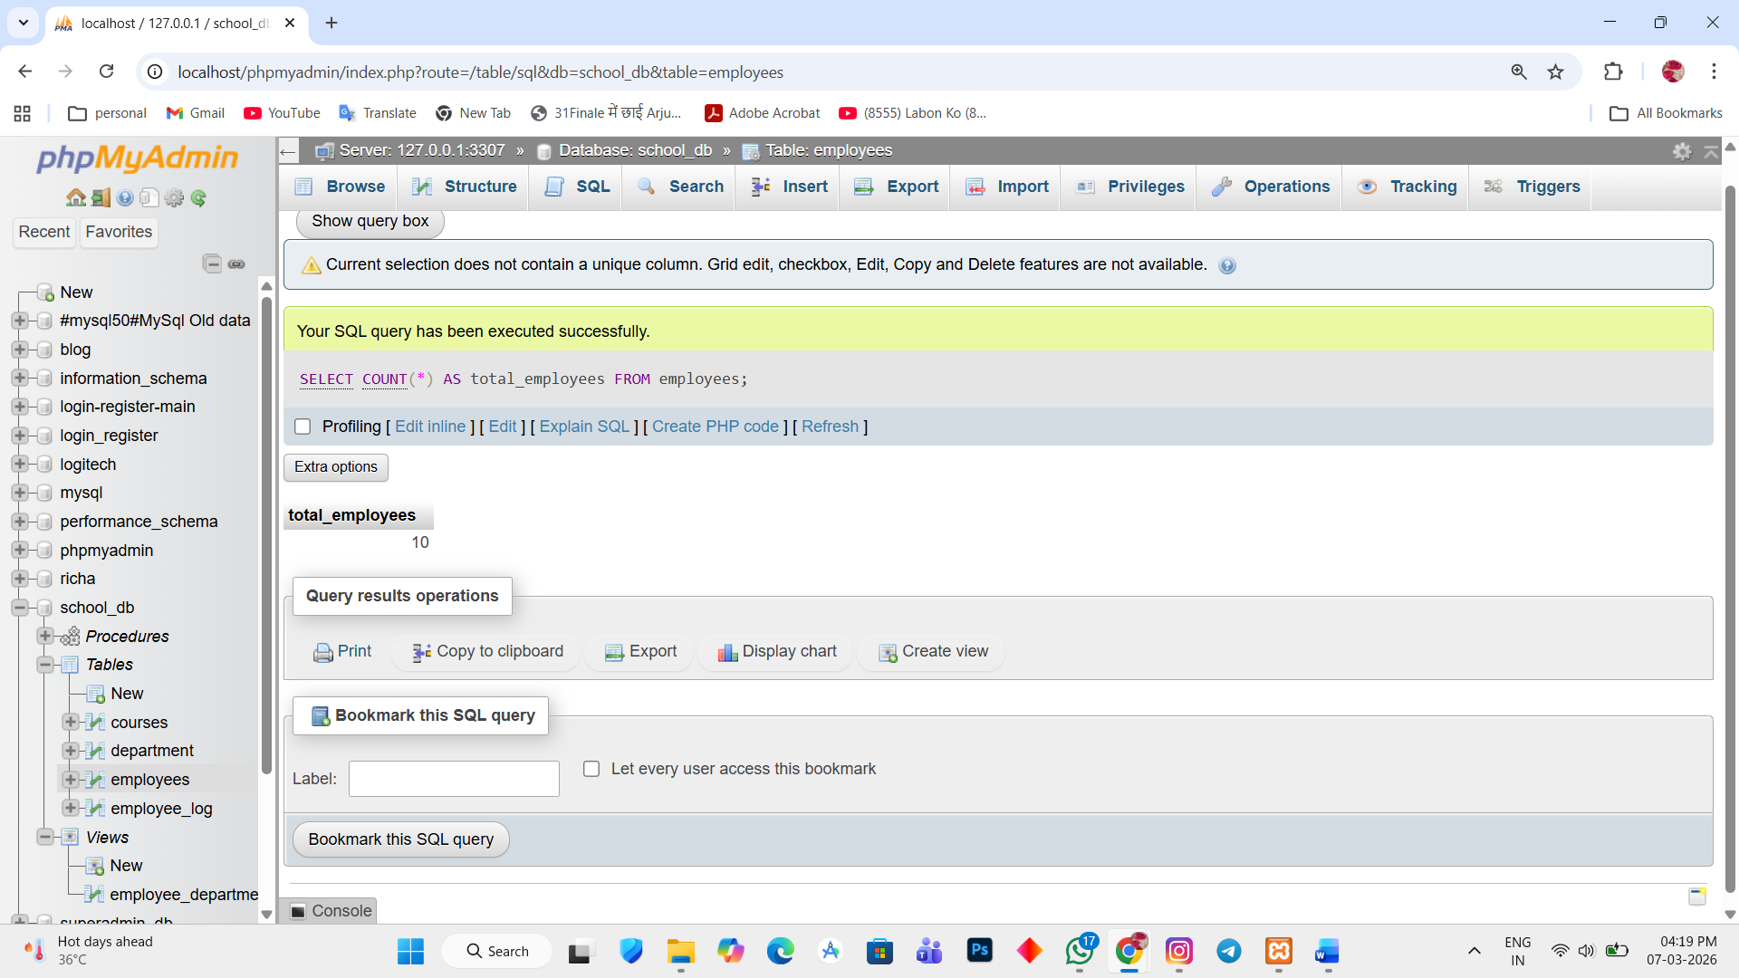

Lab 2.
Create a PL / SQL block that calculates the total sales from an orders table.
Ans.
Create order table
1. CREATE TABLE orders (order_id INT PRIMARY KEY AUTO_INCREMENT, customer_name varchar(255), amount int);
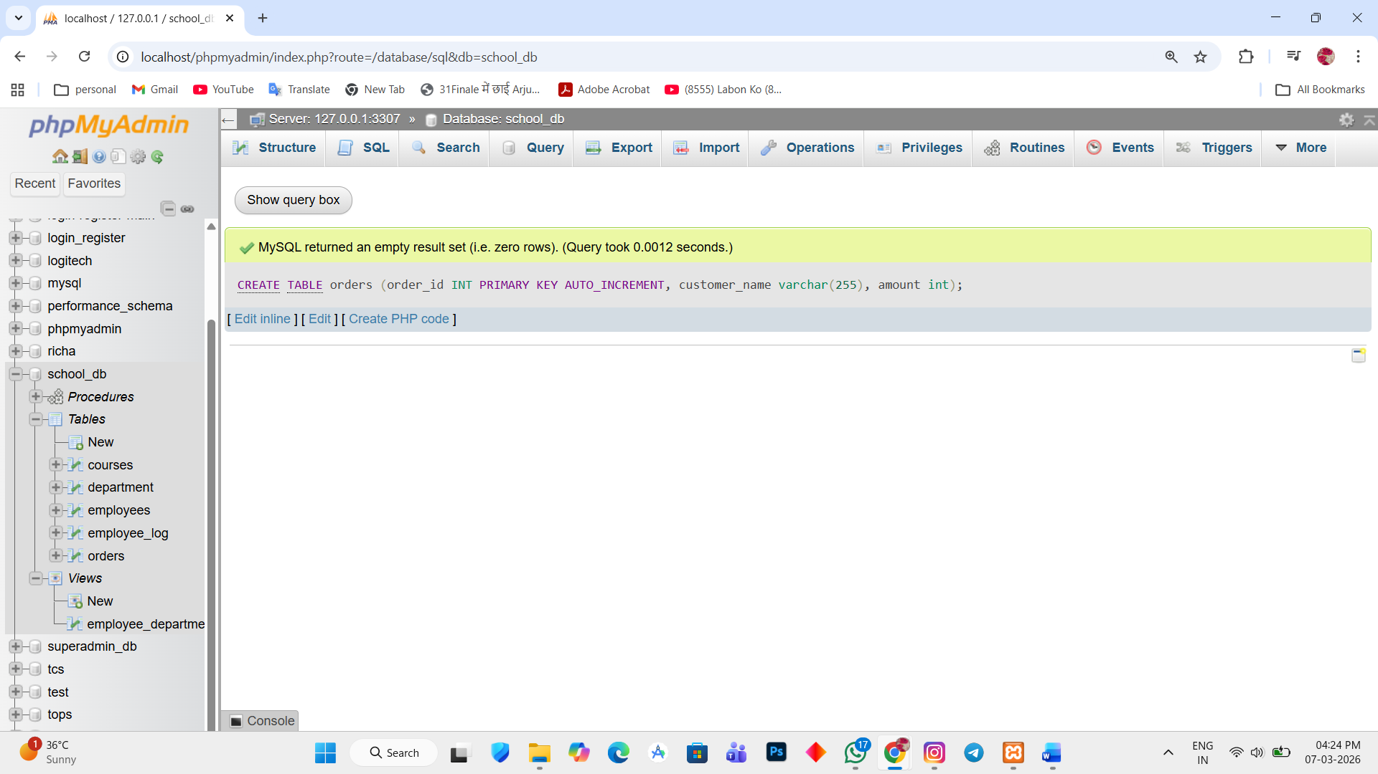

2. insert some record
INSERT INTO orders(customer_name, amount) VALUES ('Richa', '5000'),('Jiyan', '6000'),('Thavan', '7000');
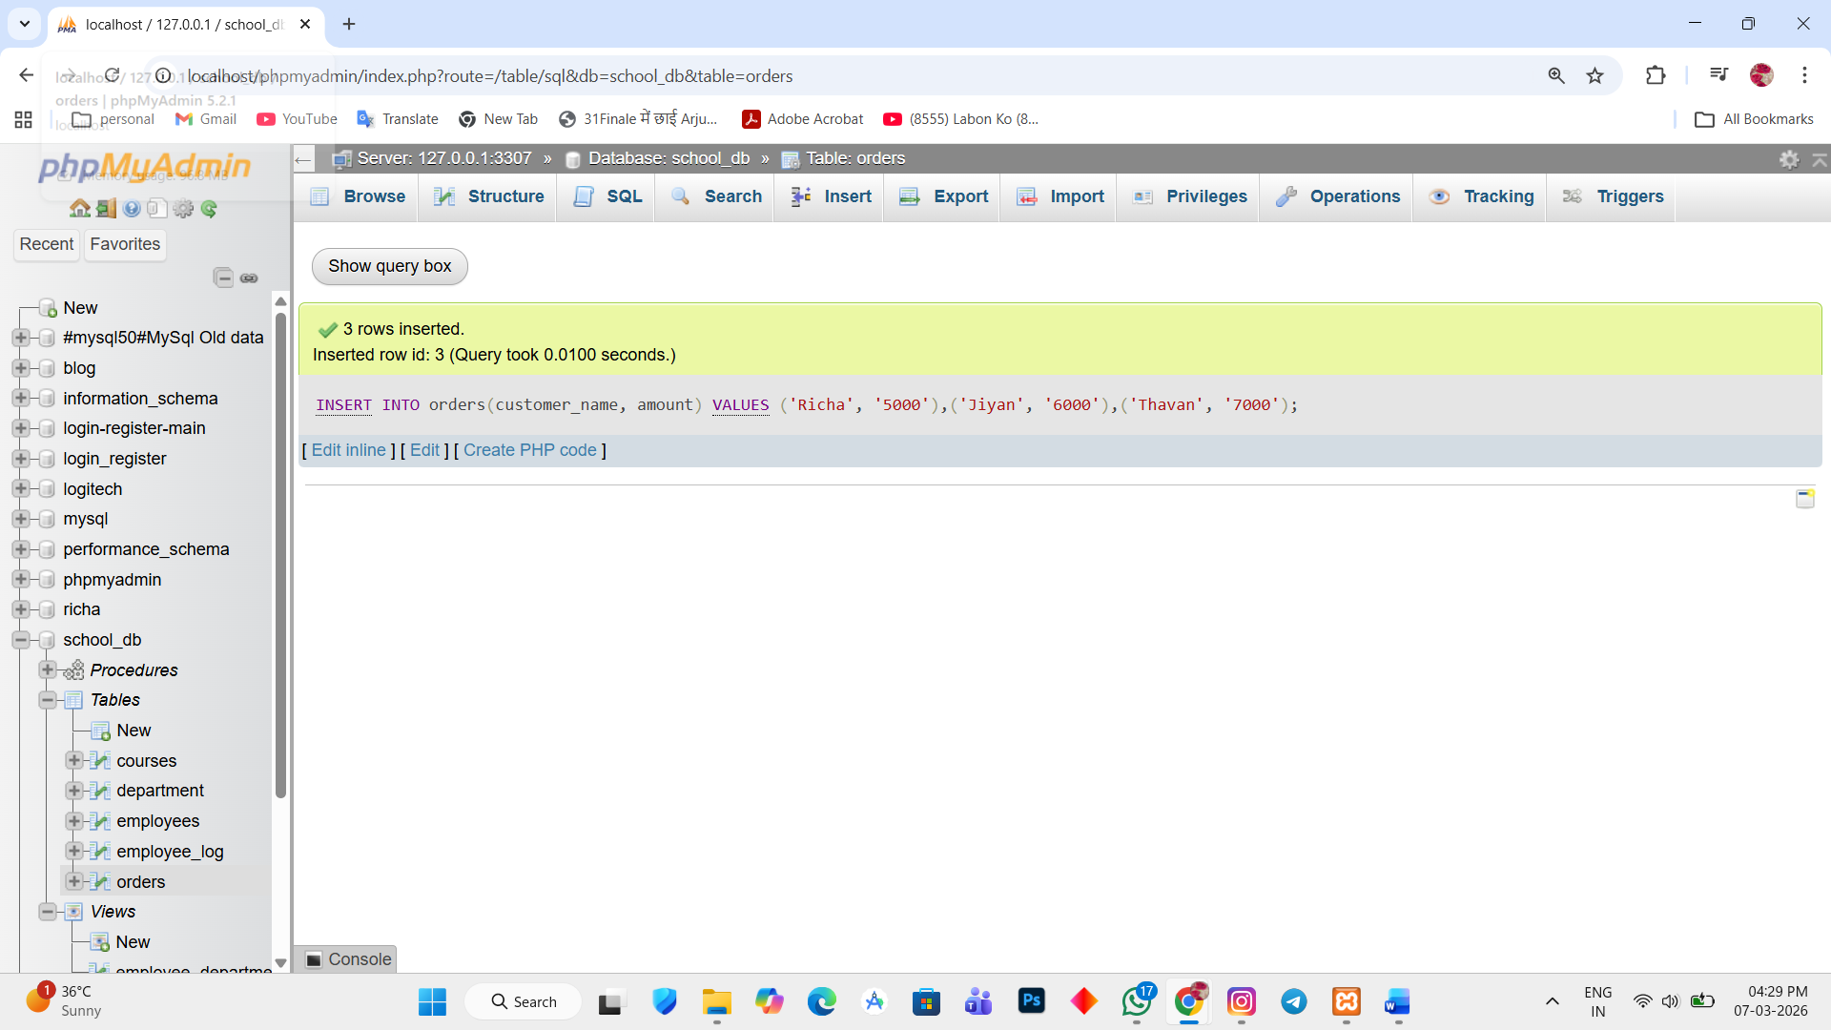

Calculate total sales
3. SELECT sum(amount) AS total_sales FROM orders;
